**IoT Introduction to Fleet Management.**

**Scenario: The customer is a pump producing company and he wants to know when, how can the pumps break or get bad. Hence, we have installed “Things” in order to measure the vibrations and few other things.**

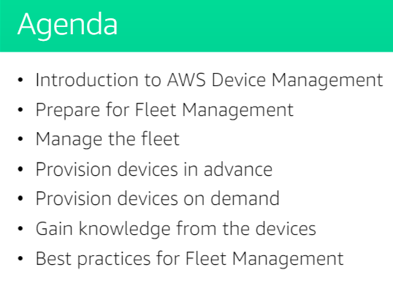

**\***Basically, Fleet management is required for managing multiple devices at a time. Here managing term means all the below mentioned processes.(in dagram)

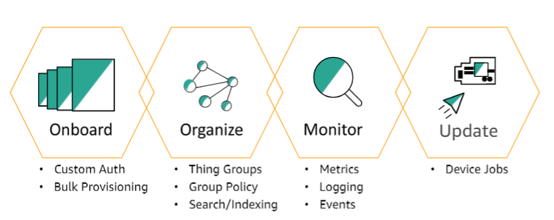

An simple example of Fleet management(This is what happens)

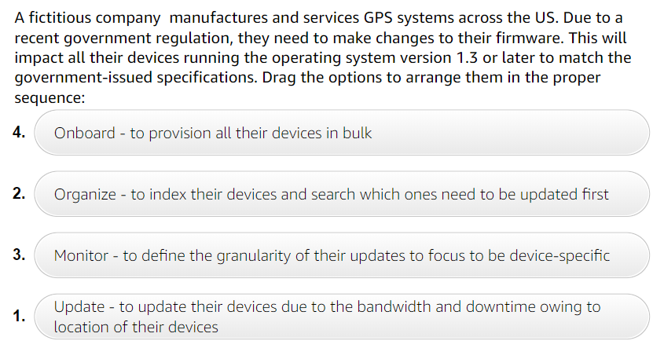

Grouping Devices (Thing Groups)

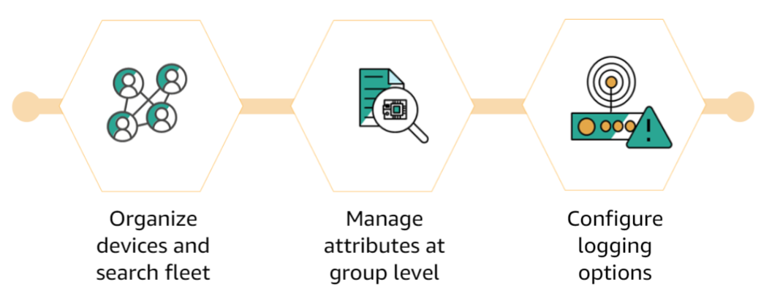

Example of thing group:

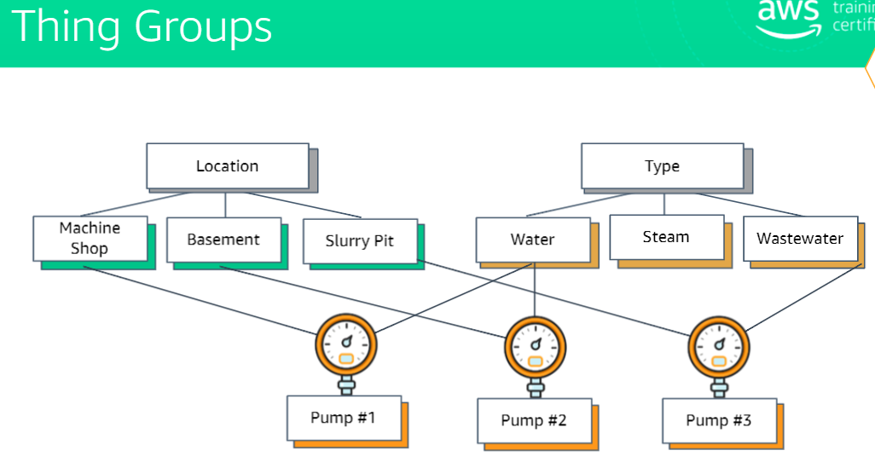

Note: Thing Groups cannot be Renamed.

Example of Thing Group Policies

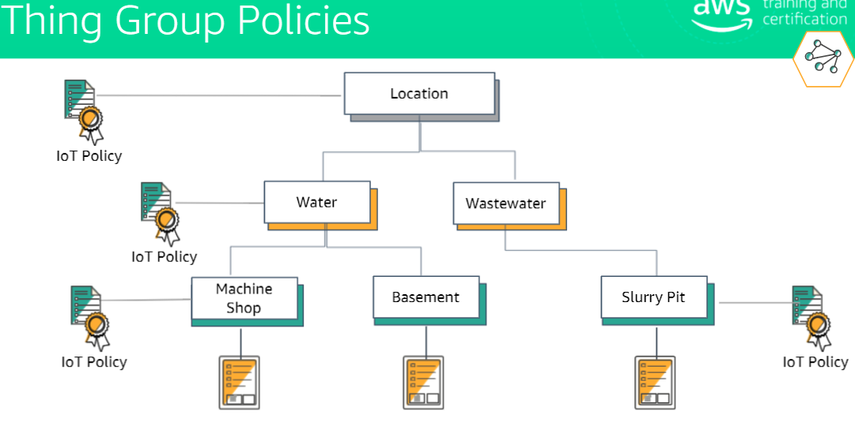

Device Provisioning:

It allows to connect your device in bulk. When you provision a device the following happens.

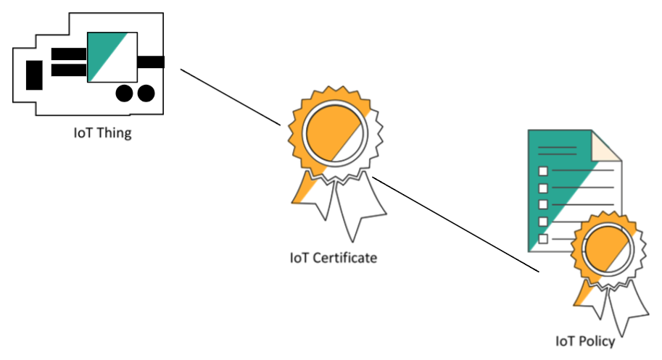

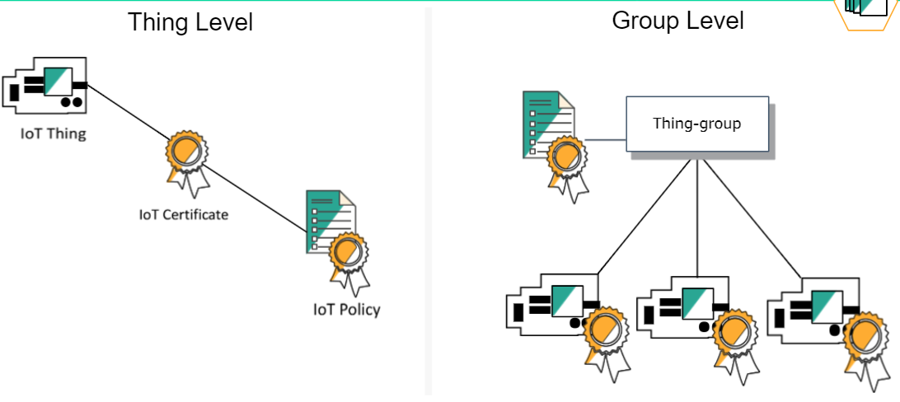

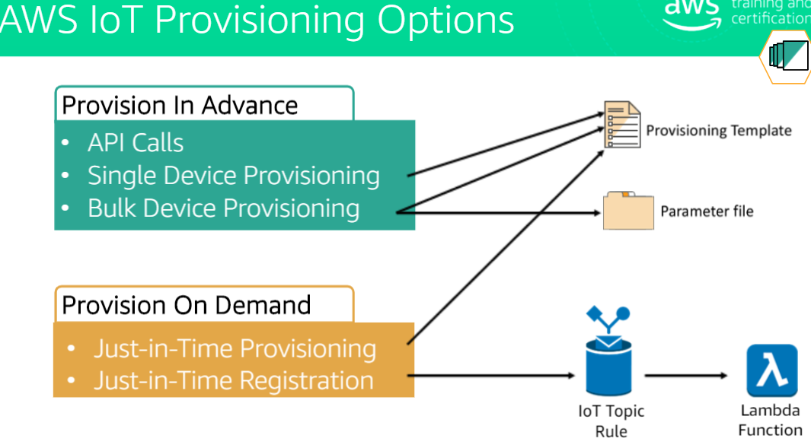

Mechanism for provisioning with API

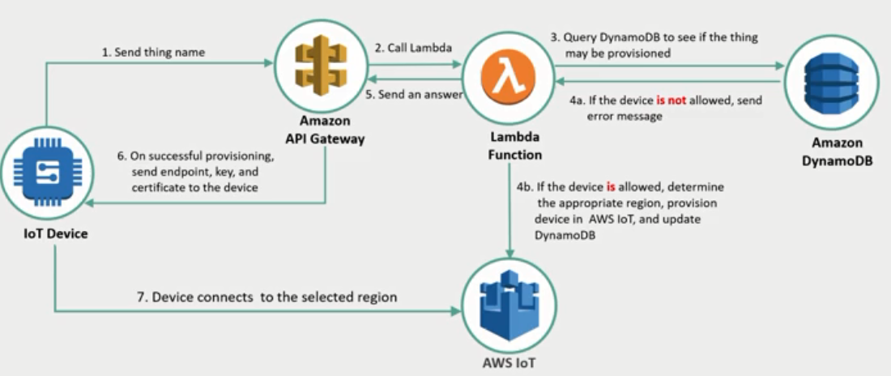

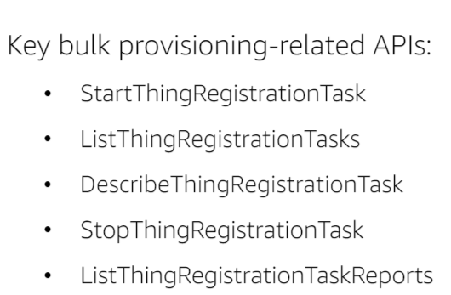

JITP(Just in Time Provisoning)

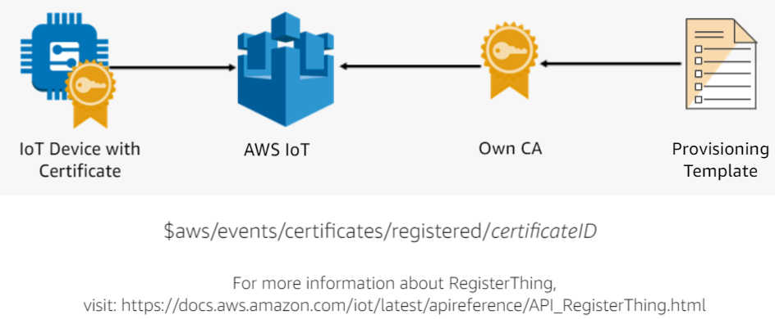

JITP(Just in time registration)

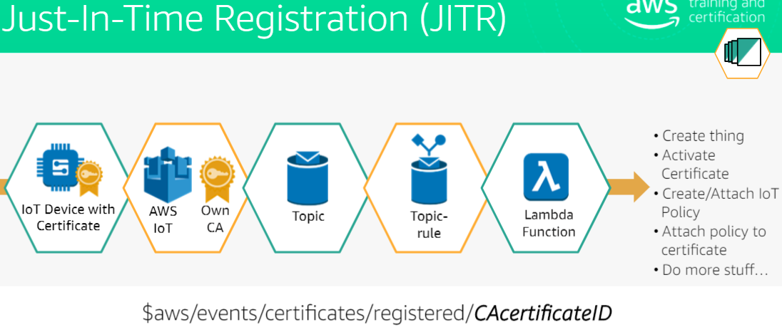

**Comparison**

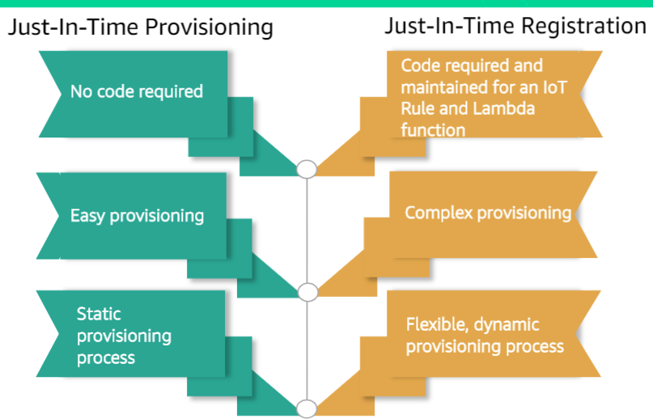

Managing the Fleet with Job agents:

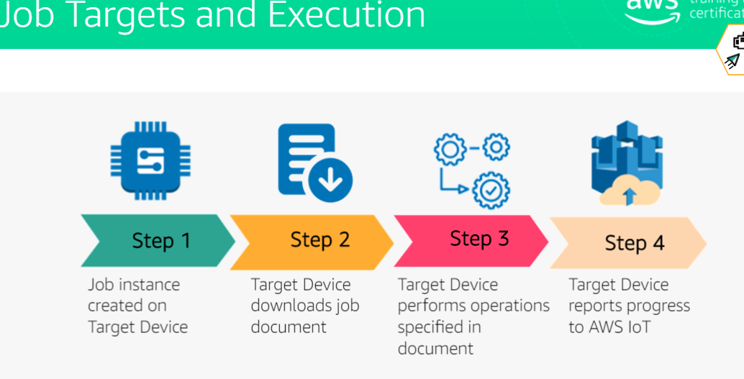

Job Agent process explained:

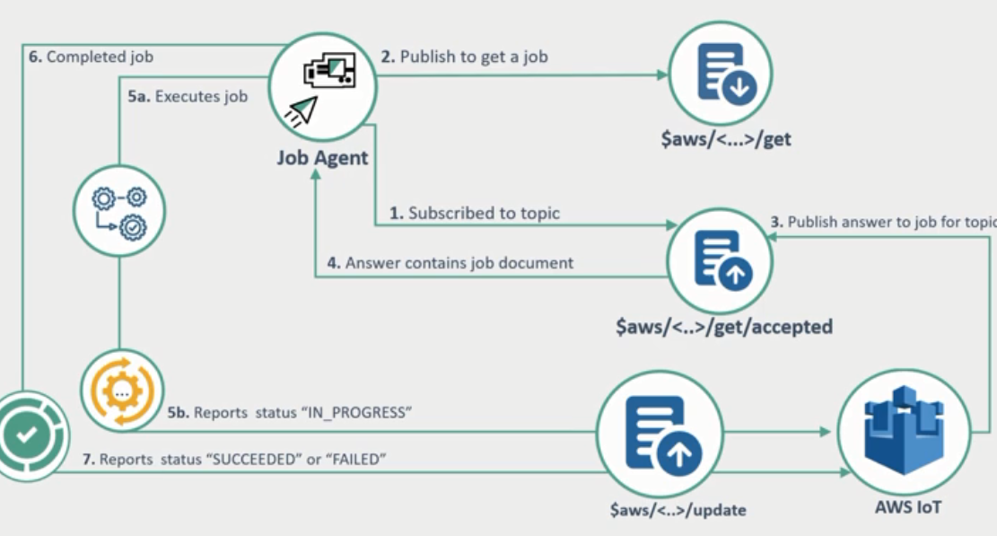

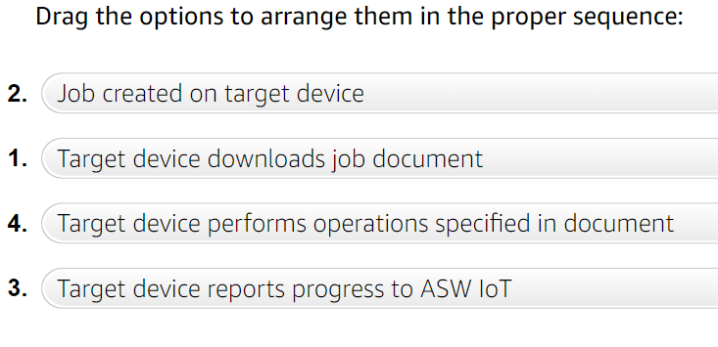

Monitoring:

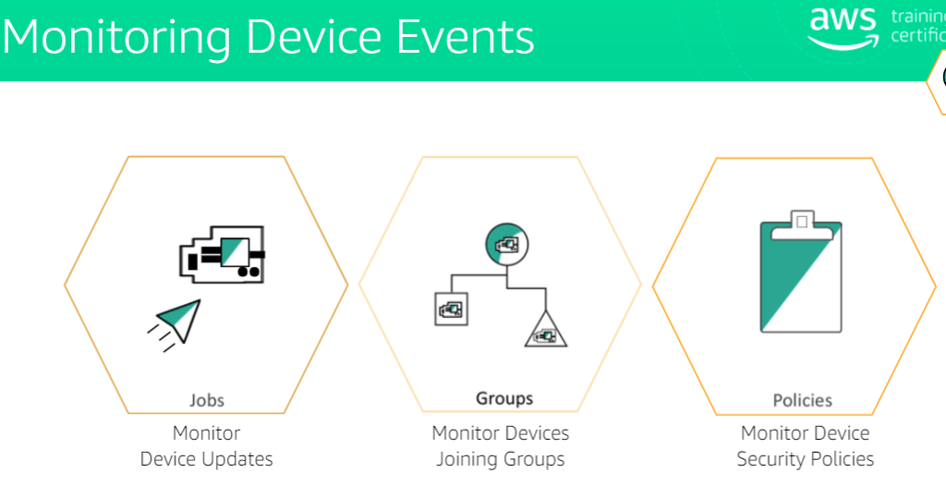

Best Practices for Things (Fleet Management):

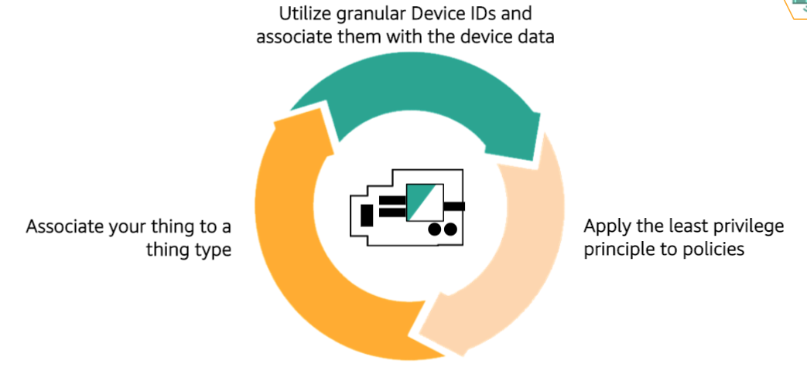

*Best Practices for Bulk provisioning:

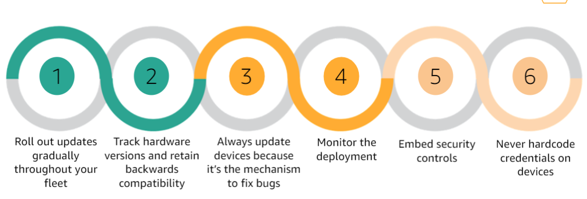

Best Practices for Jobs

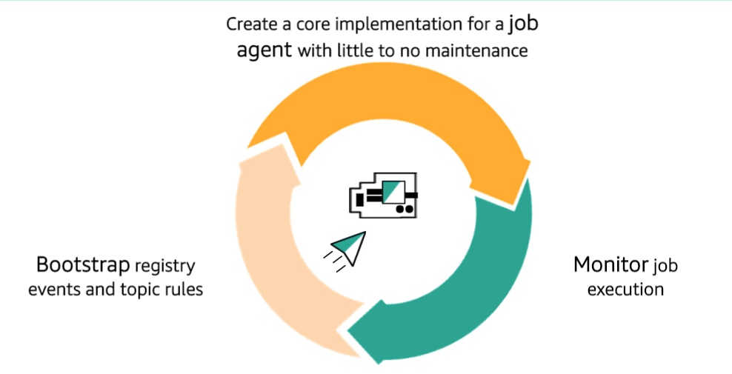

Best Practices for Securing Devices:

